Disclaimer:
All templates provided by The Velvet Ledger serve as a starting point for your documents. They are intended for general assistance only and should not be considered legal, financial, or professional advice. Before distributing or implementing any document, consult a qualified professional to ensure compliance and adequate protection for your business.

Truck Inspection REport
Inspector |  | Date and Time
Noted damage

Left Side | Front
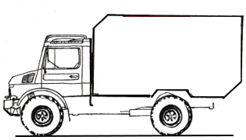 | 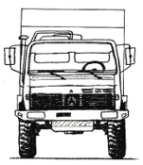
Right Side | Rear
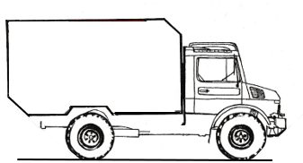 | 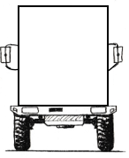

Key
B | Bent | BR | Broken | C | Cut | CR | Cracked | D | Dented | F | Faded
FF | Foreign Fluid | L | Loose | M | Missing | P | Pitted | PC | Paint Chip | R | Rubbed
RU | Rust | S | Scratched | SL | Soiled | ST | Stained | SW | Swirl Marks | T | Torn

Cause of Damage
Action Required

Declaration
Signature |  | Date

OFFICE USE ONLY
Incident Report  Completed | Maintenance Form  Completed | Repairs  Completed | Disciplinary Action  Taken

Reviewed
Name |  | Position
Signature |  | Date

